VDA Publication Request Form

Name
Address
City, State, Zip Code
Phone (w/Area Code)
Fax
E-mail Address

# | Topic | # | Topic
 | Area Agencies on Aging  (list with contact information) |  | Independent Living, tips for adaptations & modifications of utensils, etc.)
 | Adult Day Care Centers |  | Long-Term Care Insurance
 | Advance Medical Directive (Living Will) |  | Long-Term Care Ombudsman Program
 | Alzheimer’s Disease & Dementia |  | Medicaid
 | Assisted Living Facilities |  | Medicare Handbook, while supplies last
 | Caregiver Information / Manual |  | Medicare Supplemental Insurance (Medigap)
 | Continuing Care Retirement Communities |  | Medicare & Medicaid  Fraud, Waste & Abuse
 | Driving – Drivers with Dementia |  | Monthly Personal Healthcare Journal, while supplies last
 | Grandparents Caring for Grandchildren |  | Prescription Drugs
 | Guardianship & Conservatorship in Virginia |  | Retirement Information Package  (for individuals living outside Virginia)
 | Home Accessibility – Earning a Tax Credit for |  | Suicide – Prevention of  in elder population
 | Housing for Seniors |  | Tax Relief Fact Flyer
 | Identity Theft - Preventing |  | Virginia Insurance Counseling & Assistance Program (VICAP)

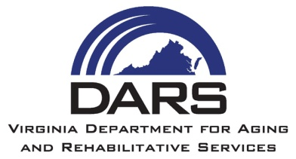 | Send this form to:
 | DARS - Virginia Division for the Aging
 | 1610 Forest Avenue, Suite 100
 | Henrico, VA 23229
 | Richmond Area: (804) 662-9333
 | Toll-Free: 1-800-552-3402
 | Fax: (804) 662-9354
 | E-mail: aging@dars.virginia.gov

